Discovering Flathead's Feathered Friends-Enhancing Schoolyard & Natl. Forest Habitat
2013 Project Update

May and June 2013, new native plant gardens took ‘root’ at West Valley School and Somers Middle School.

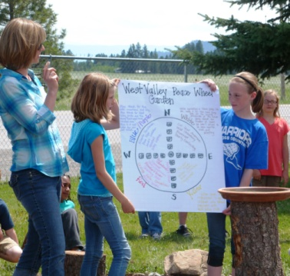
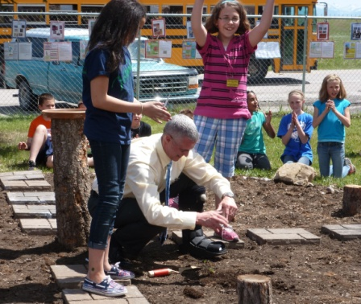
At West Valley School teachers, students, parents, Master Gardener volunteers, Flathead Audubon members, and Flathead National Forest employees, worked together to place plants in the school’s native plant garden. Before the planting started, 4th grade students presented a short planting ceremony, describing the garden medicine wheel design and the research students did to select and place plants in the garden. The school principal with help from students put in the first plant.
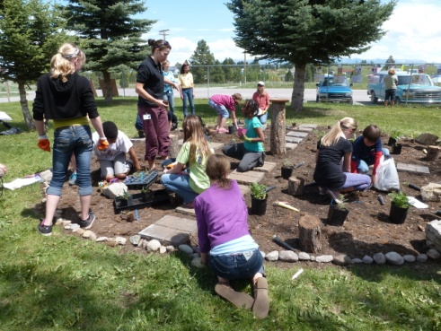

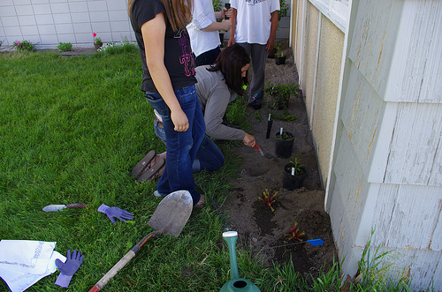
Through the school year, West Valley and Somers Middle School teachers, students and volunteers researched native plants, selected specific species for planting, designed the garden layout and created the planting beds. The gardens will provide habitat for area birds, butterflies and insects and offer a hands-on outdoor classroom for students. Somers Middle School students are hoping the garden will attract more pollinators for the school vegetable garden and greenhouse.

For West Valley School the garden project kicked off the creation of a middle school “Garden Club’. In September, the ‘garden team’ began phase two of their garden project, designing and laying out another plant bed and putting in selected shrubs and forbs.
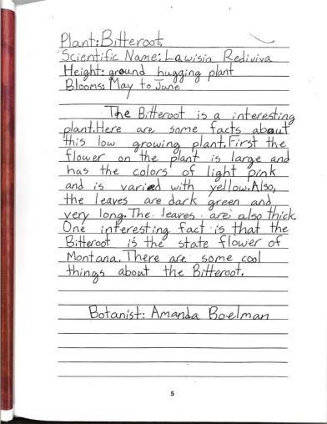
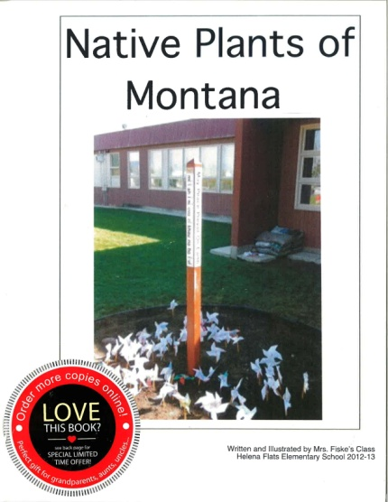

Helena Flats School followed up the planting of their garden with the creation of a Native Plants of Montana book that captured what students learned, gave the community information about the plants in their native garden and offered a great assessment tool.

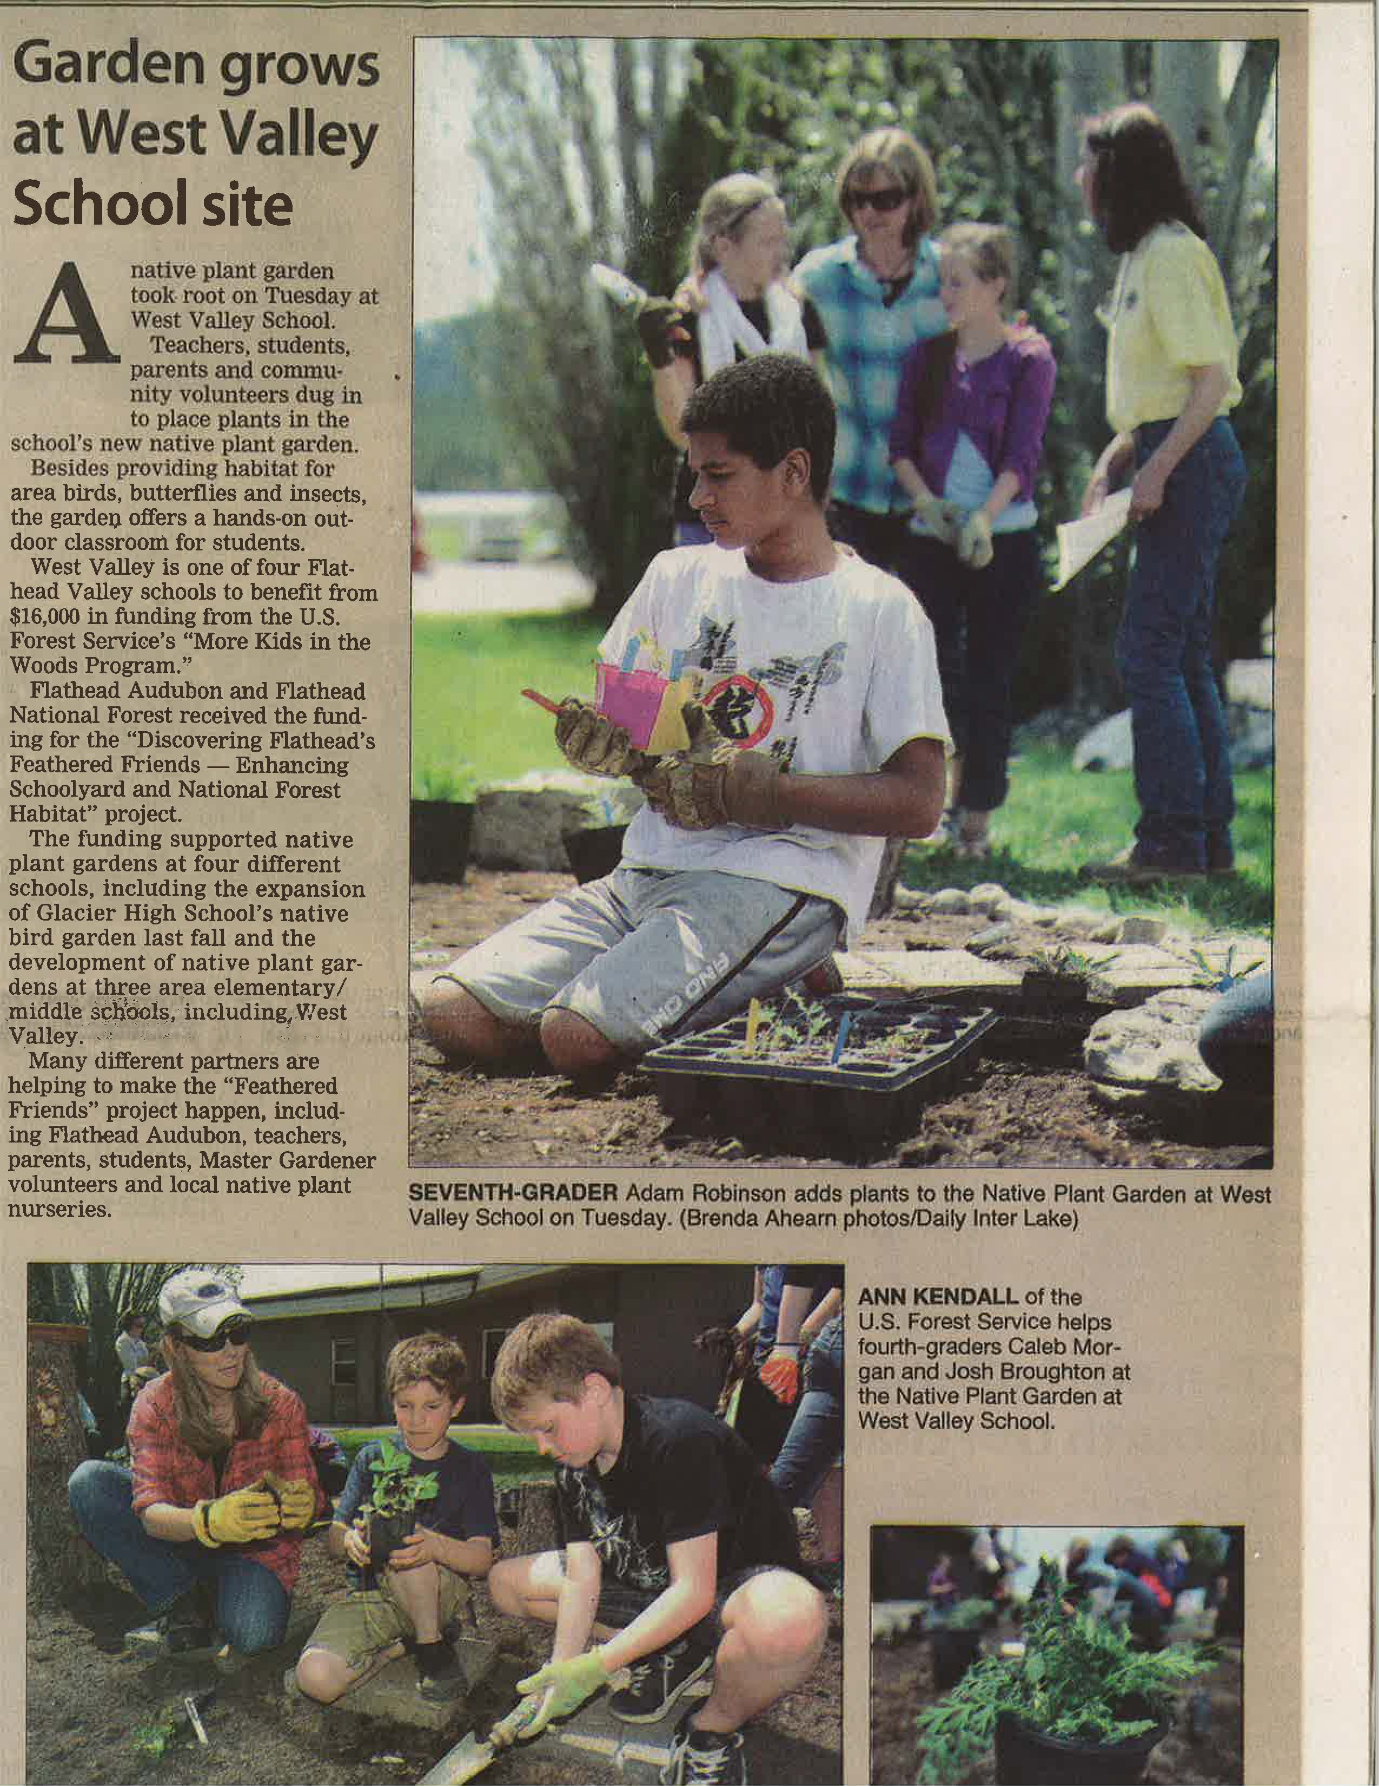
Daily Inter Lake article, May 25, 2013 (Kalispell)

